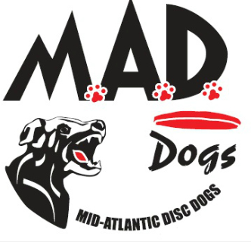
Mid-Atlantic Disc Dogs presents - Disc Dog Clinic with
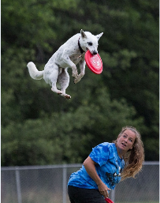
Chuck Middleton & Tracy Custer
When: May 6th – May 9th
Where: Camp Saginaw, Oxford, PA
https://www.campsaginaw.com/

2 CAMP OPTIONS AVAILABLE

CAMP ONLY
- 5 nights of accommodations (shared cabin or private room, we will do our best to group people as requested)
- All meals included beginning with dinner on May 5th and ending with lunch on May 10th

$650.00 Shared Cabin, including all meals and expenses (per person)
(2 to 3 people per cabin; twin beds and shared bathroom)
$740.00 Private Bedroom / Bathroom, including all meals and expenses (per person)
(Approximately 10’ x 10’ with queen bed and private bathroom)

CAMP PLUS COMPETITION WEEKEND
- 7 nights of accommodations (shared cabin or private room, we will do our best to group people as requested)
- All meals included beginning with dinner on May 5th and ending with lunch on May 12th

$740.00 Shared Cabin, including all meals and expenses (per person)
(2 to 3 people per cabin; twin beds and shared bathroom)
$830.00 Private Bedroom / Bathroom, including all meals and expenses (per person)
(Approximately 10’ x 10’ with queen bed and private bathroom)

*If we have received enough entries to hold the camp, deposits are non-refundable if you cannot attend (unless your spot can be filled from the waitlist). If by April 1st we have not met the minimum number of participants you will receive a full refund of monies sent.

Disc Dog Clinic with Chuck Middleton & Tracy Custer
When: May 6th – May 9th
Where: Camp Saginaw, Oxford, PA

REGISTRATION FORM
Name: Date: Address: Phone: Email:
Payment in full is appreciated at the time of registration or you can opt to pay in 3 installments.

CAMP ONLY:
Shared Cabin Share with

Private Room / Bathroom

The 3 payment plan is:
  - $250 Deposit Due at time of registration
  - $200 Shared Cabin / $245 Private Cabin Due March 20th
  - $200 Shared Cabin / $245 Private Cabin Due April 20th

CAMP PLUS COMPETITION WEEKEND:
Shared Cabin Share with

Private Room / Bathroom

The 3 payment plan is:
- $250 Deposit Due at time of registration
- $245 Shared Cabin / $290 Private Cabin Due March 20th
- $245 Shared Cabin / $290 Private Cabin Due April 20th

Release and Waiver of Liability
For and in consideration of my participation in the Mid Atlantic Disc Dogs (MAD Dogs) event, and for other good and valuable consideration, the receipt and sufficiency of which are hereby acknowledged, I the undersigned, intending to be legally bound do hereby for myself, my heirs, assigns, executors and administrators, waive and release any and all rights and claims for damages or injuries arising out of, or in any way related to, my participation in the Event, which I may have against the following party: MAD Dogs, the administration and owner of the facility hosting the Event; together with the contractor, agents, employees and representatives of each of them. I certify that my canine and I are healthy and fit to compete in the Event.
I hereby grant to MAD Dogs the exclusive right to record, broadcast, photograph, film and videotape my performances and related interviews at the Event and to utilize such recordings, broadcasts, photographs, films or videotapes together with my name, image, likeness, voice, and biographical information, for such publicity, promotional or commercial purposes as they may desire. I understand that MAD Dogs may assign the right to use the recordings, broadcasts, images, photographs, film and videotape of my performance(s) together with my name, image, likeness, voice and biographical information to such person or other entity (including, but not limited to a television broadcaster) as they may desire without my further consent or knowledge and I expressly agree to such assignment.
Signature: _Date:

Please direct any questions to Criss Brown at startariot0107@gmail.com
Mail Registration & Deposits to: Criss Brown 106 Norway Drive, Mohnton, PA 19540 OR
email registration form and Pay Online via Square

